CAS Syllabus

https://www.casact.org/admissions/syllabus/ExamMASI.pdf

<https://newonlinecourses.science.psu.edu/stat510/lesson/3/3.3>

3.3 Forecasting with ARIMA Models

<https://newonlinecourses.science.psu.edu/stat510/lesson/3/3.3#paragraph--289>

## Standard error of the forecast error for a forecast using an ARIMA model [Section](https://newonlinecourses.science.psu.edu/stat510/lesson/3/3.3#paragraph--289)

Without proof, we’ll state a result:

The variance of the difference between the forecasted value at time *n + m* and the (unobserved) value at time *n + m*is

Variance of (xn+mn−xn+m)=σw2∑j=0m−1Ψj2.

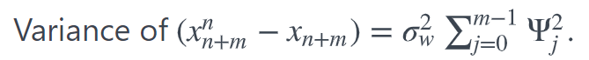

Thus the estimated **standard deviation of the forecast error** at time *n + m* is

Standard error of (xn+mn−xn+m)=σ^w2∑j=0m−1Ψj2.

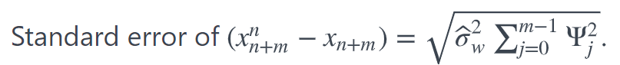

**Note!**  
The summation of squared psi-weights begins with (Ψ0)2=1 and that the summation goes to *m – 1*, one less than the number of times ahead for which we’re forecasting.

When forecasting *m* = 1 time past the end of the series, the standard error of the forecast error is

Standard error of (xn+1n−xn+1)=σ^w2(1)

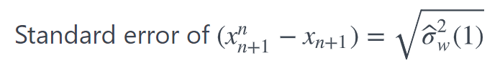

When forecasting the value *m* = 2 times past the end of the series, the standard error of the forecast error is

Standard error of (xn+2n−xn+2)=σ^w2(1+Ψ12).

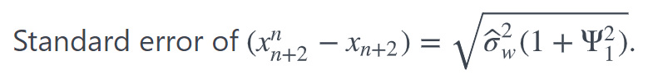

Notice that the variance will not be too big when *m* = 1. But, as you predict out farther in the future, the variance will increase. When *m* is very large, we will get the total variance. In other words, if you are trying to predict very far out, we will get the variance of the entire time series; as if you haven't even looked at what was going on previously.

95% Prediction Interval for xn+m

With the assumption of normally distributed errors, a 95% prediction interval for xn+m, the future value of the series at time *n + m*, is

xn+mn±1.96σ^w2∑j=0m−1Ψj2.

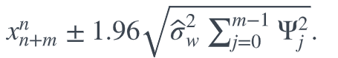

Also: <http://people.missouristate.edu/songfengzheng/Teaching/MTH548/Time%20Series-ch09.pdf>

